Assignment 1: Debugging Transformer Models with PyCharm and WSL

43 Snapshots with Shape & Role Explanations (Encoder–Decoder Transformer)

# Objective

Debugger-based walkthrough of a standard encoder–decoder Transformer using **PyCharm + WSL**. We include **43 numbered snapshots**, each with the exact variable, the **shape**, and a short explanation of **what it represents and why the shape is correct**.

# Environment (PyCharm + WSL) — Optional but Recommended

If available, include:

* **Env-1:** PyCharm interpreter set to WSL (screenshot: env1.png).
* **Env-2:** Debugger hit with Variables pane visible (screenshot: env2.png).

# Model & Data Compliance

* **Transformer:** Encoder–decoder (Vaswani et al., 2017), **2** encoder layers, **2** decoder layers, **4**

heads, *d*model = 128, *d*ff = 256.

* **Source (6 tokens):** hello from cairo egypt team project
* **Target (5 tokens):** we are debugging transformer today
* **Shapes used throughout:** batch = 1; src_len = 6; tgt_len = 5; heads = 4; *d*head =

*d*model*/*4 = 32.

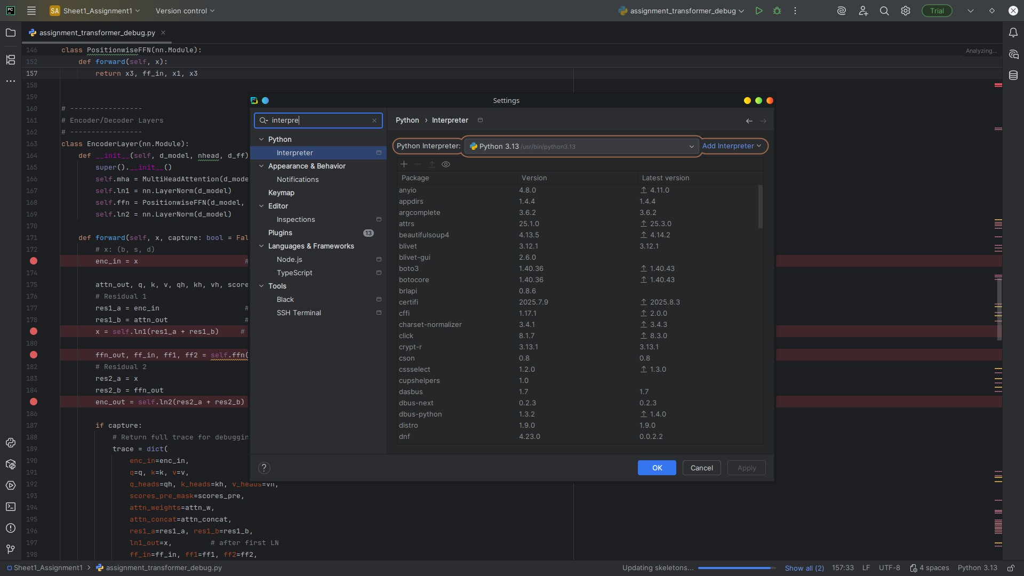

Figure 1: PyCharm interpreter configuration on Linux (instead of WSL).

# Input & Embedding (Snapshots 1–5)

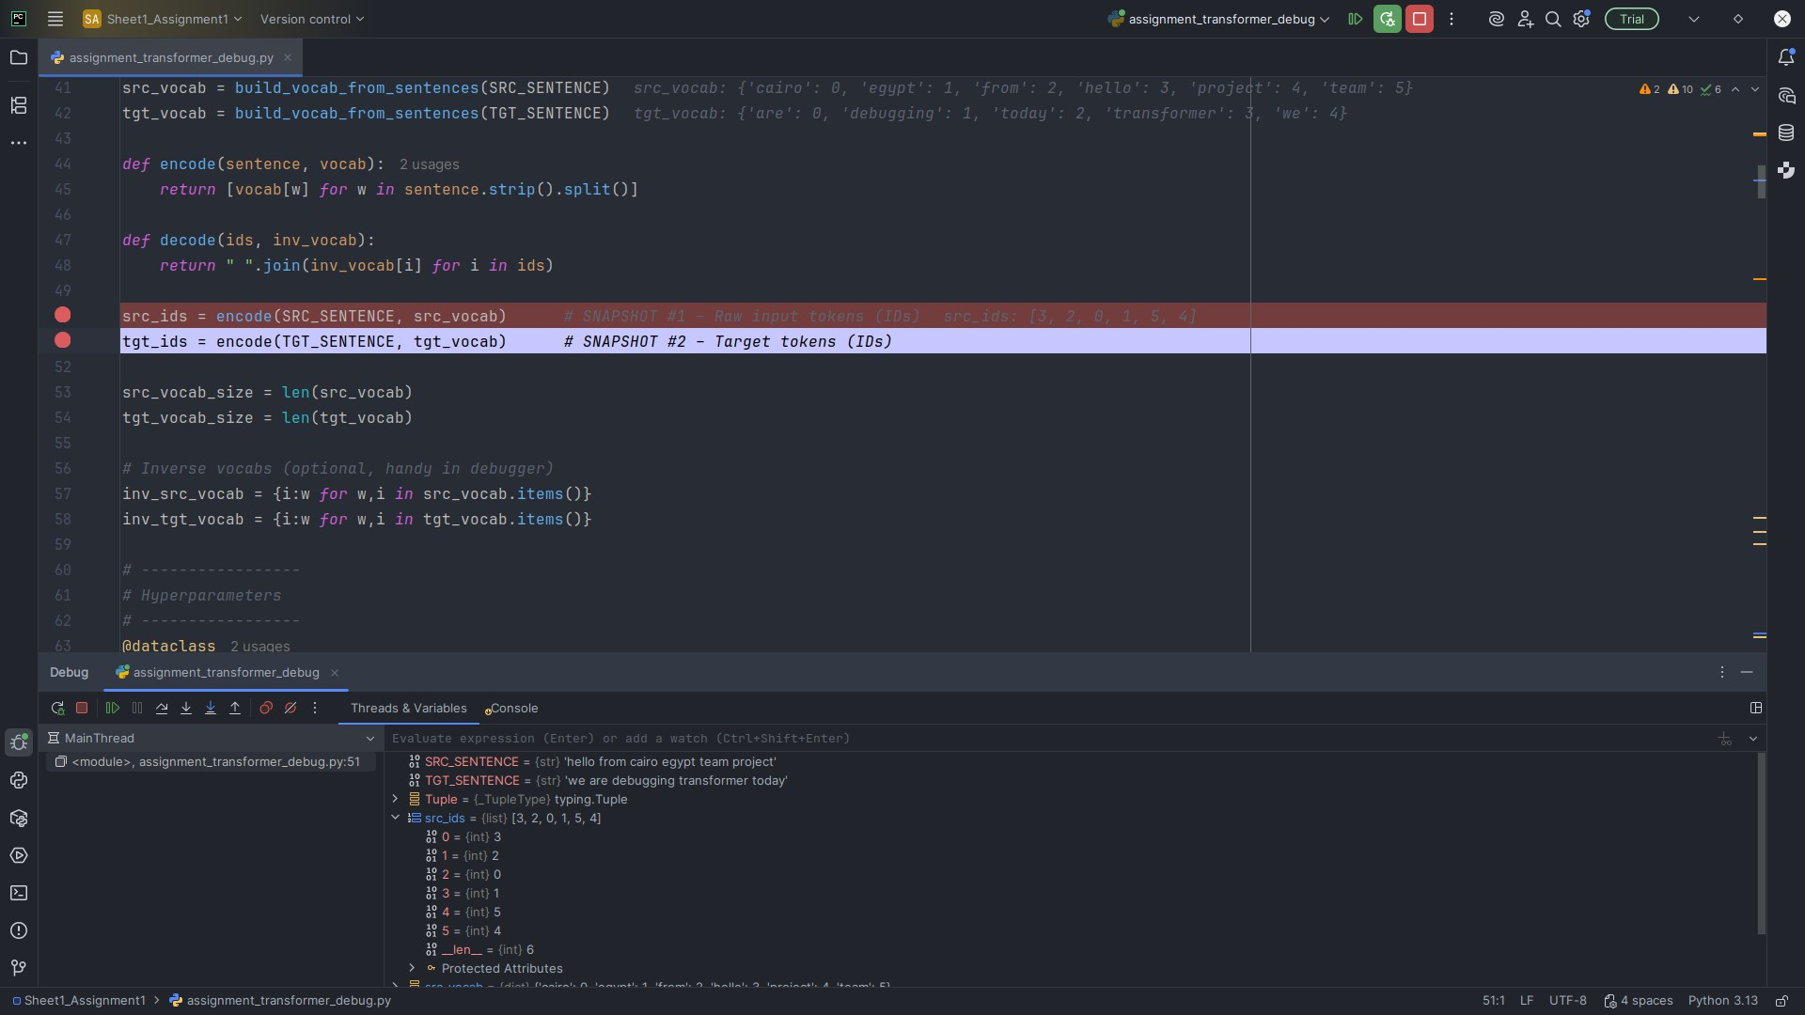

Snapshot #1 — Raw input tokens (IDs)

**Explanation & Shape**

**Variable (as shown in PyCharm):** src_ids

**Observed shape:** (6,)

Integer IDs for each source token; length equals the source sequence length (6). This is the discrete input to the embedding lookup.

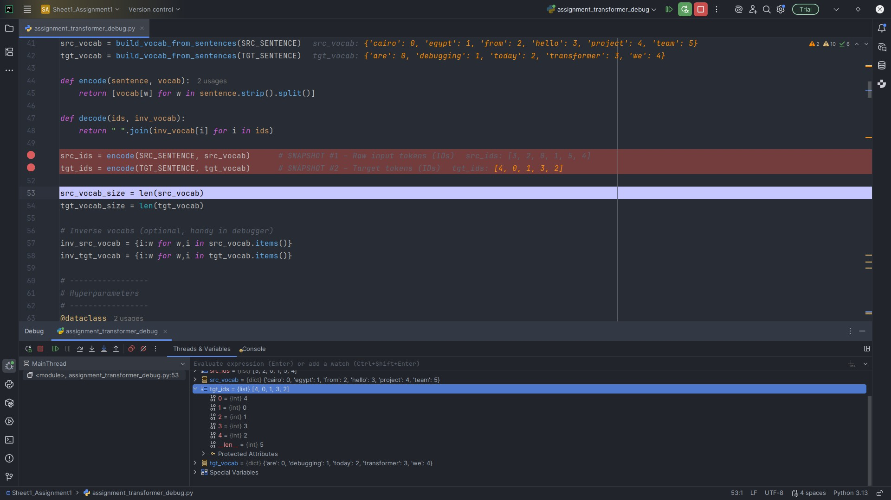

Snapshot #2 — Target tokens (IDs)

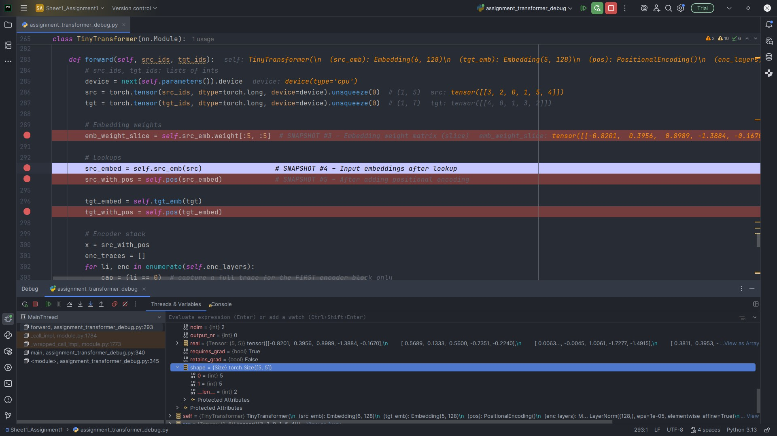

**Explanation & Shape**

**Variable (as shown in PyCharm):** tgt_ids

**Observed shape:** (5,)

Integer IDs for each target token; length equals the target sequence length (5) used for teacher forcing.

Snapshot #3 — Embedding weight matrix (slice)

**Explanation & Shape**

**Variable (as shown in PyCharm):** refs["emb_weight_slice"]

**Observed shape:** (5,5) slice of full (src_vocab_size, 128)

A small slice of the learnable embedding table. Rows = vocabulary items; columns = 128 embedding features. The full table is (vocab*,* 128).

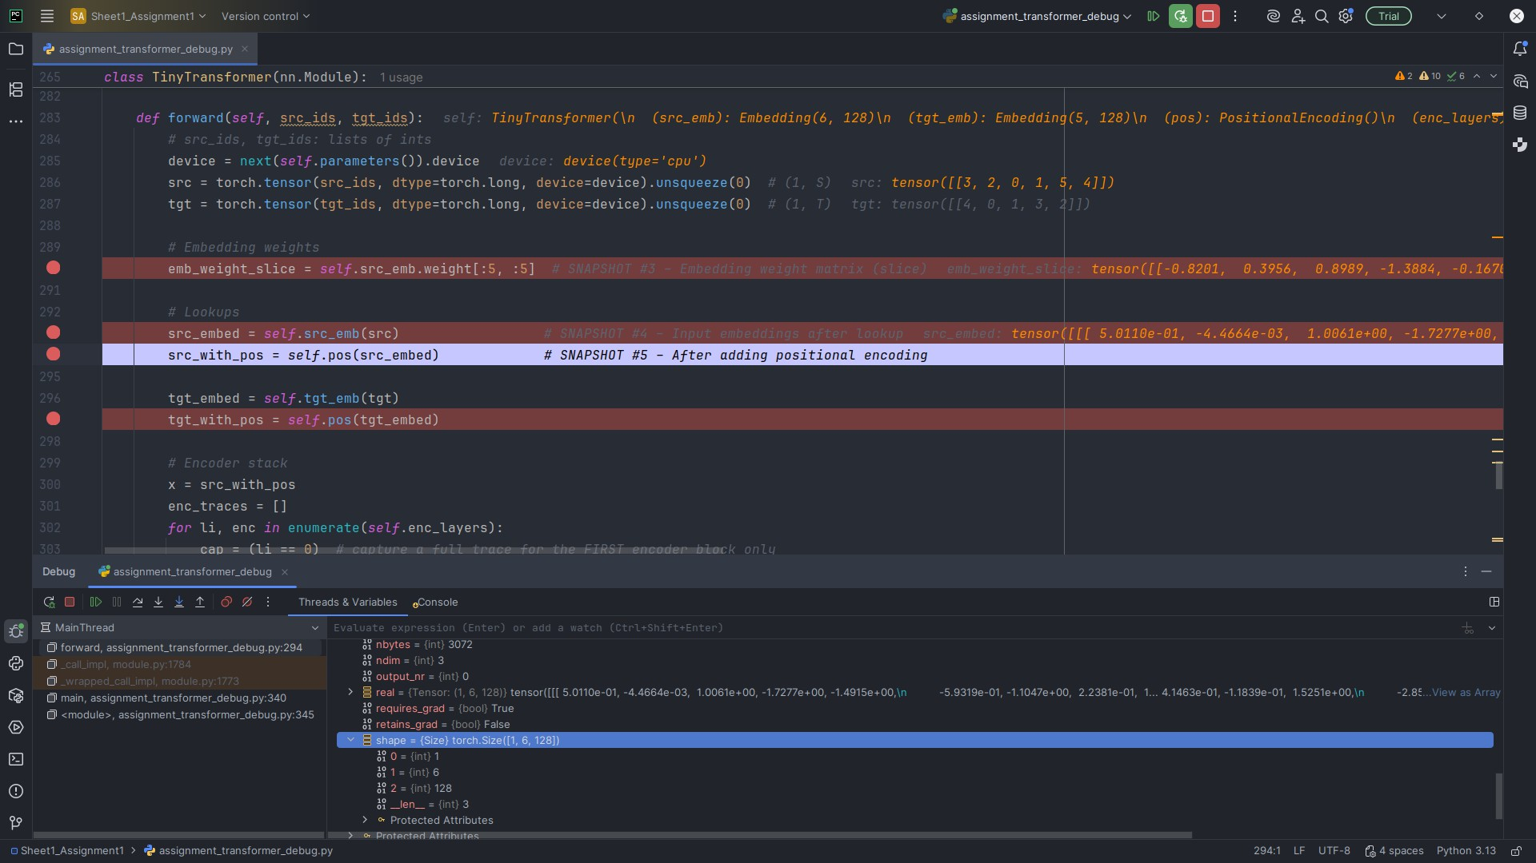

Snapshot #4 — Input embeddings after lookup

**Explanation & Shape**

**Variable (as shown in PyCharm):** refs["src_embed"]

**Observed shape:** (1,6,128)

Each source token ID is mapped to a 128-d vector. Batch size is 1, sequence length is 6, and

*d*model = 128.

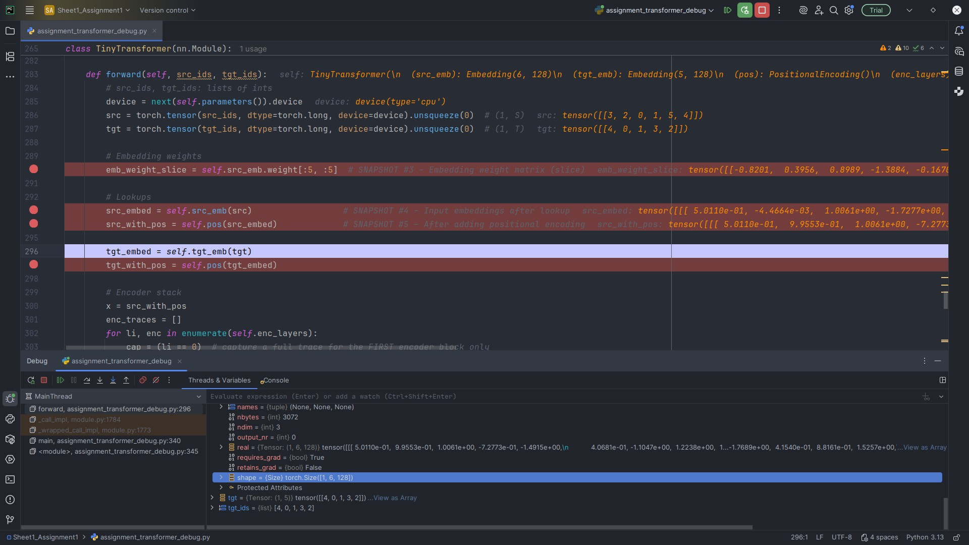

Snapshot #5 — Embeddings after adding positional encoding

**Explanation & Shape**

**Variable (as shown in PyCharm):** refs["src_with_pos"]

**Observed shape:** (1,6,128)

Sinusoidal positional encodings are added element-wise to embeddings to encode order; shape remains (1*,* 6*,* 128).

# Encoder (One Block, Full Trace) — Snapshots 6–19

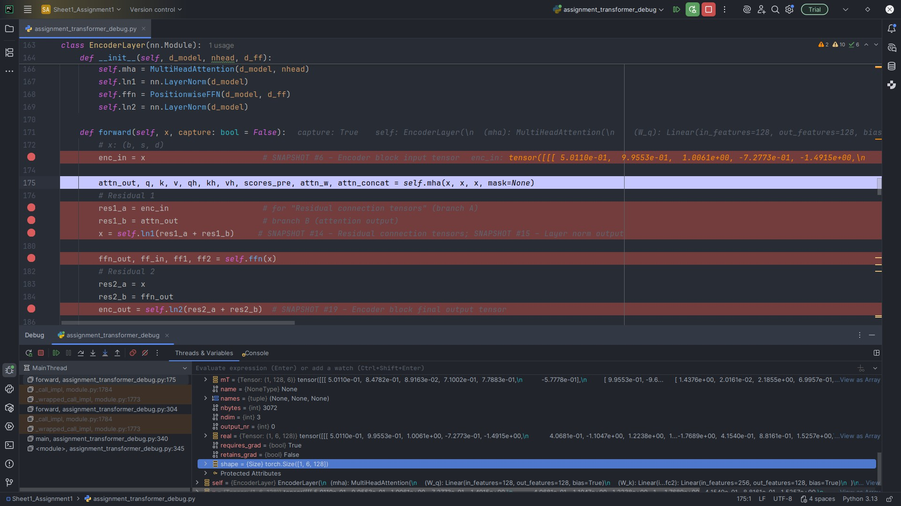

Snapshot #6 — Encoder block input tensor

**Explanation & Shape**

**Variable (as shown in PyCharm):** refs["enc_traces"][0]["enc_in"]

**Observed shape:** (1,6,128)

Tensor entering the first encoder layer (embeddings + position). Per-token dimension remains 128.

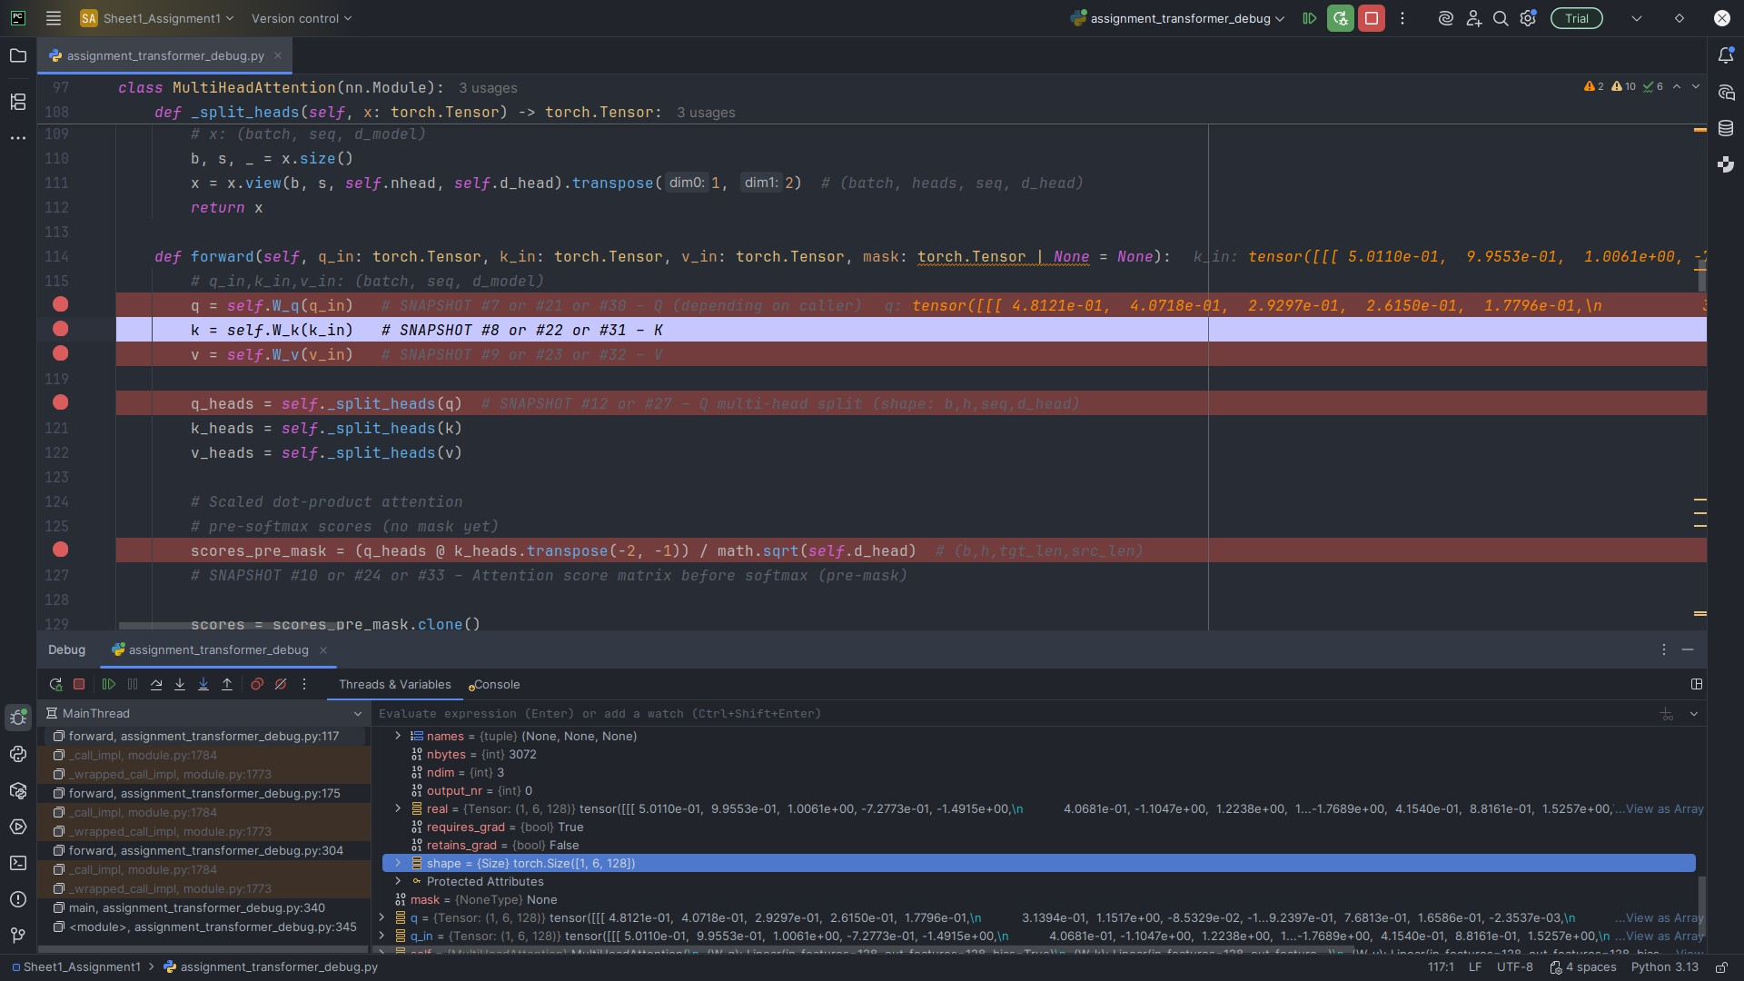

Snapshot #7 — Self-attention queries (Q)

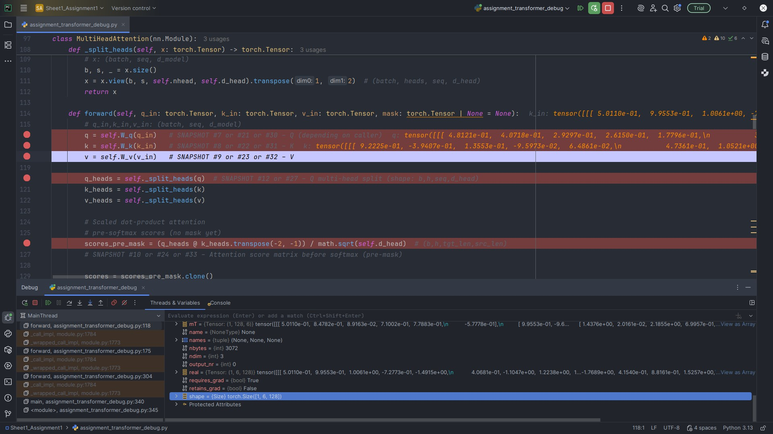

**Explanation & Shape**

**Variable (as shown in PyCharm):** refs["enc_traces"][0]["q"]

**Observed shape:** (1,6,128)

Q is a linear projection of the encoder input. Q, K, and V share the same shape so dot-product attention is valid in the same representation space.

Snapshot #8 — Self-attention keys (K)

**Explanation & Shape**

**Variable (as shown in PyCharm):** refs["enc_traces"][0]["k"]

**Observed shape:** (1,6,128)

K is another linear projection representing addresses/features compared against Q. Same shape ensures *QK𝖳* is defined.

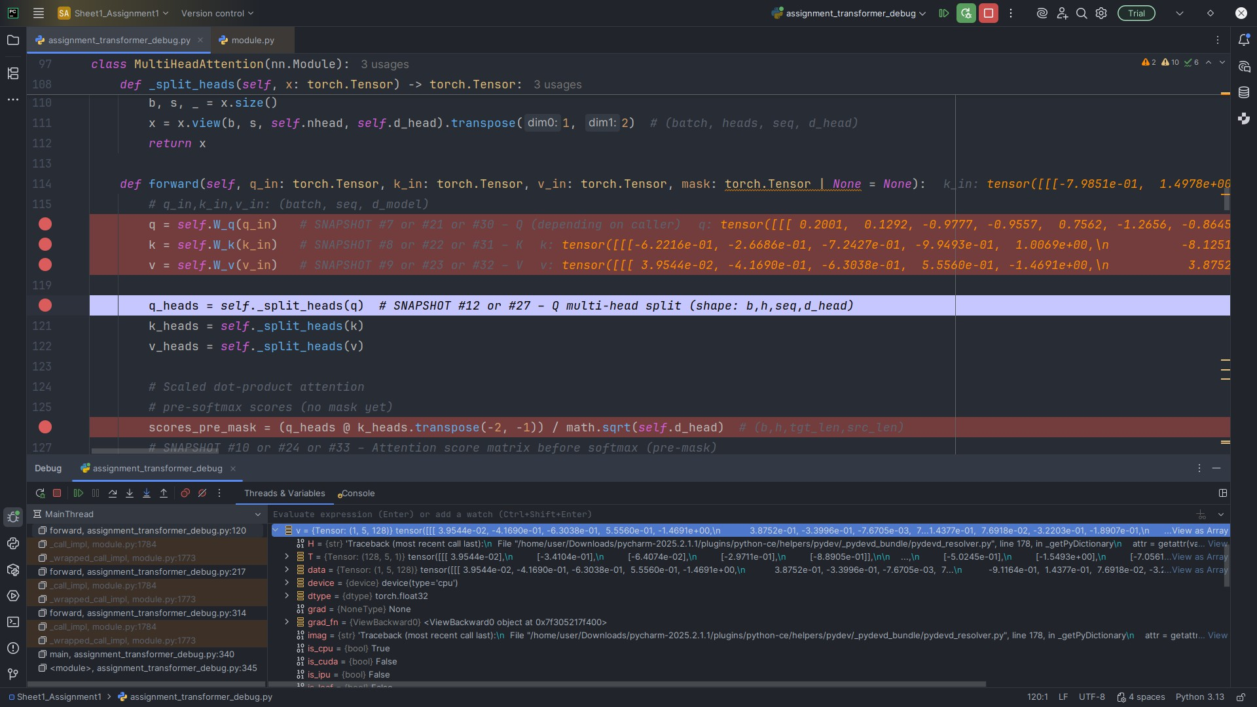

Snapshot #9 — Self-attention values (V)

**Explanation & Shape**

**Variable (as shown in PyCharm):** refs["enc_traces"][0]["v"]

**Observed shape:** (1,6,128)

V carries the features to aggregate via attention weights. Same shape keeps residuals compatible.

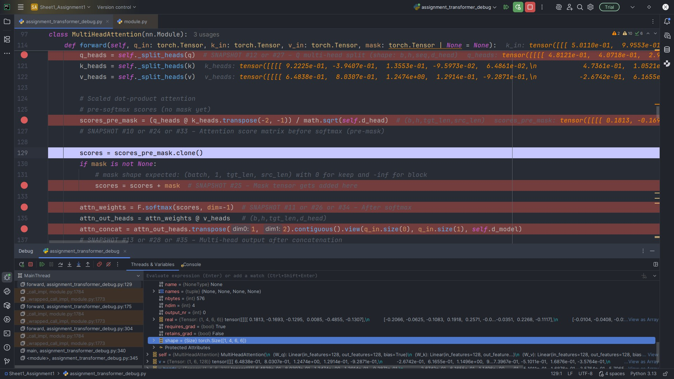

Snapshot #10 — Attention scores before softmax

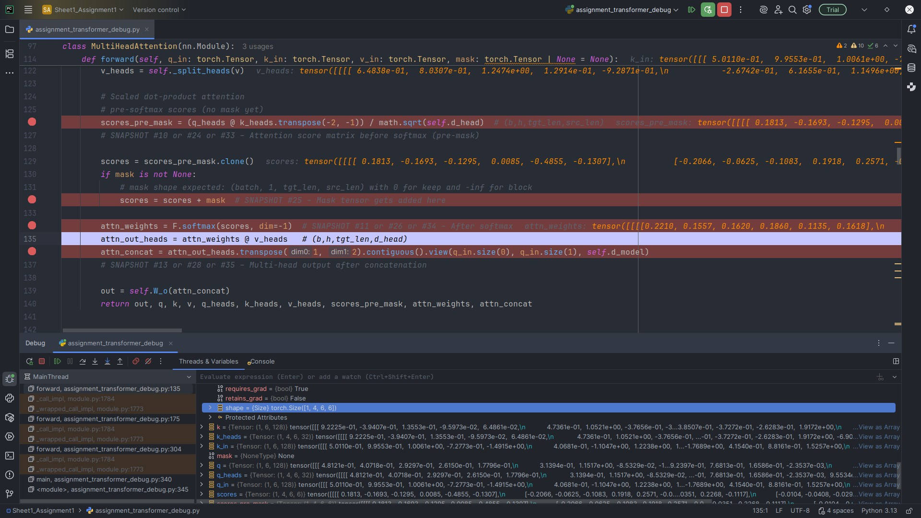

**Explanation & Shape**

**Variable (as shown in PyCharm):** refs["enc_traces"][0]["scores_pre_mask"]

**Observed shape:** (1,4,6,6)

Per-head scaled dot products *QK𝖳/*√*d*head. Square 6 × 6 because encoder self-attends over

the same sequence.

Snapshot #11 — Attention scores after softmax

**Explanation & Shape**

**Variable (as shown in PyCharm):** refs["enc_traces"][0]["attn_weights"]

**Observed shape:** (1,4,6,6)

Row-wise probabilities per head; each row sums to ≈ 1. These weights mix V.

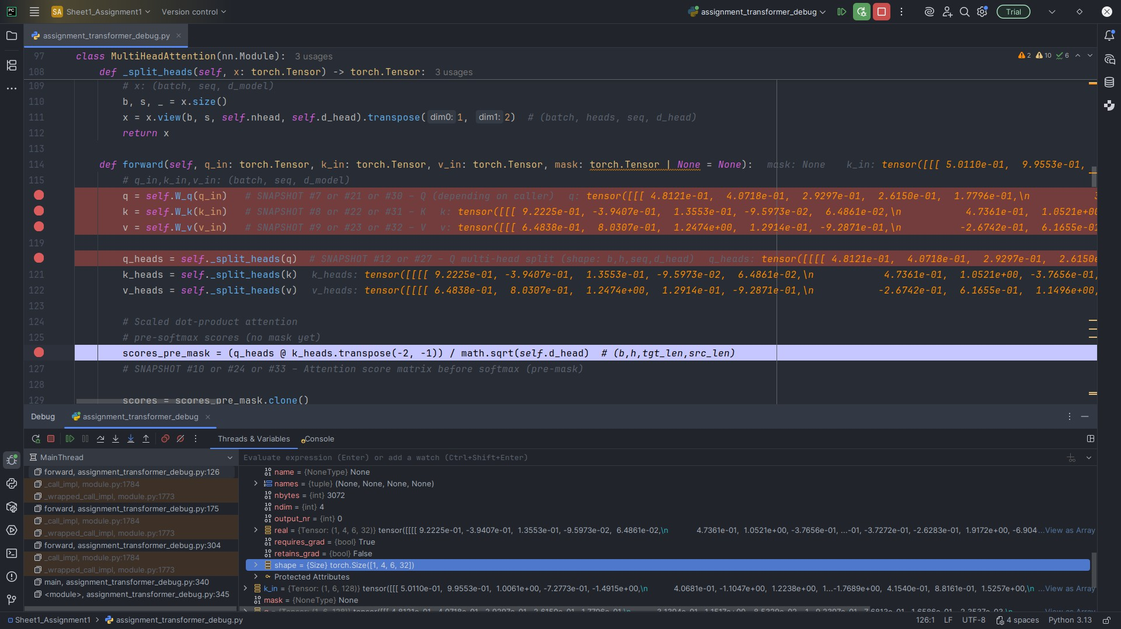

Snapshot #12 — Multi-head split (Q/K/V)

**Explanation & Shape**

**Variable (as shown in PyCharm):** refs["enc_traces"][0]["q_heads"] (& k_heads, v_heads)

**Observed shape:** (1,4,6,32) each

Split *d*model = 128 into 4 heads of 32 to capture diverse relations in parallel.

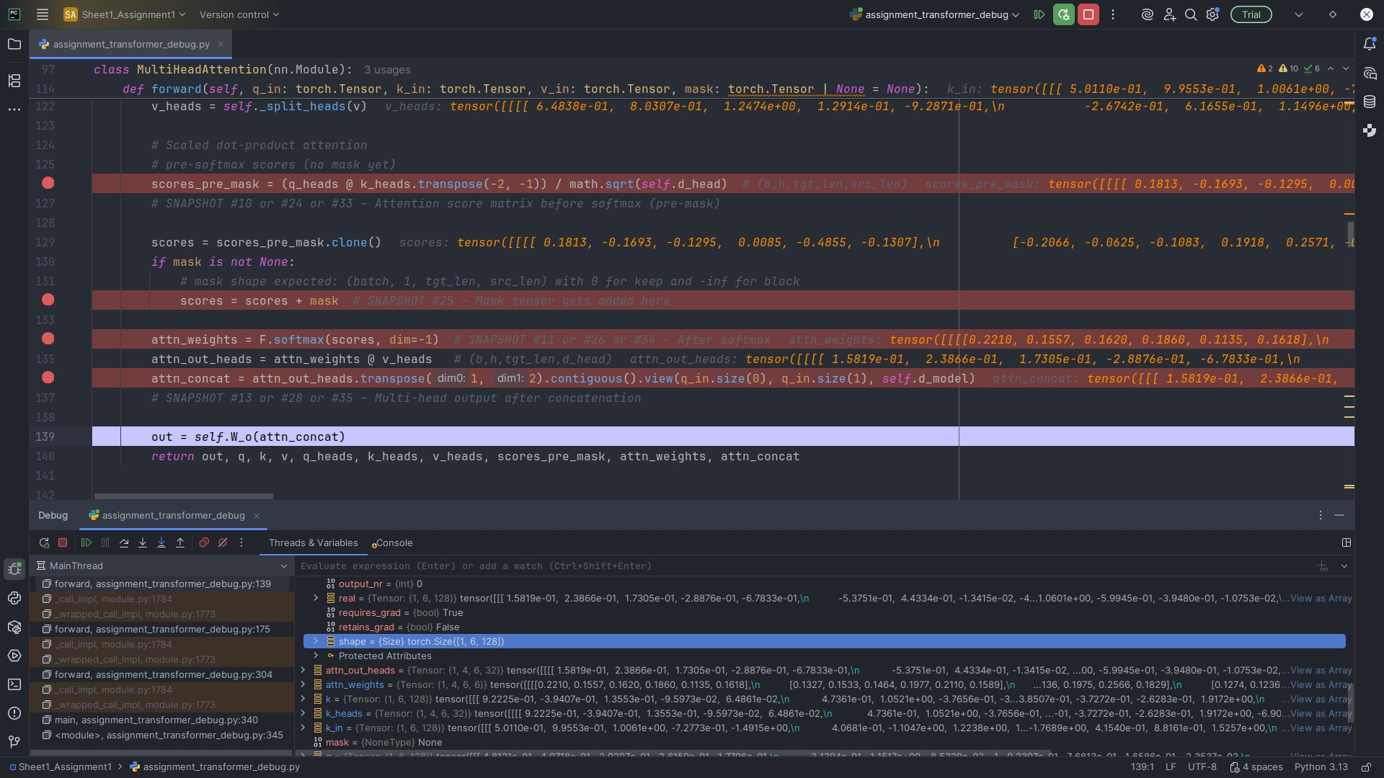

Snapshot #13 — Multi-head attention output after concatenation

**Explanation & Shape**

**Variable (as shown in PyCharm):** refs["enc_traces"][0]["attn_concat"]

**Observed shape:** (1,6,128)

Per-head outputs (1*,* 4*,* 6*,* 32) are concatenated to (1*,* 6*,* 128), restoring model dimension for residual addition.

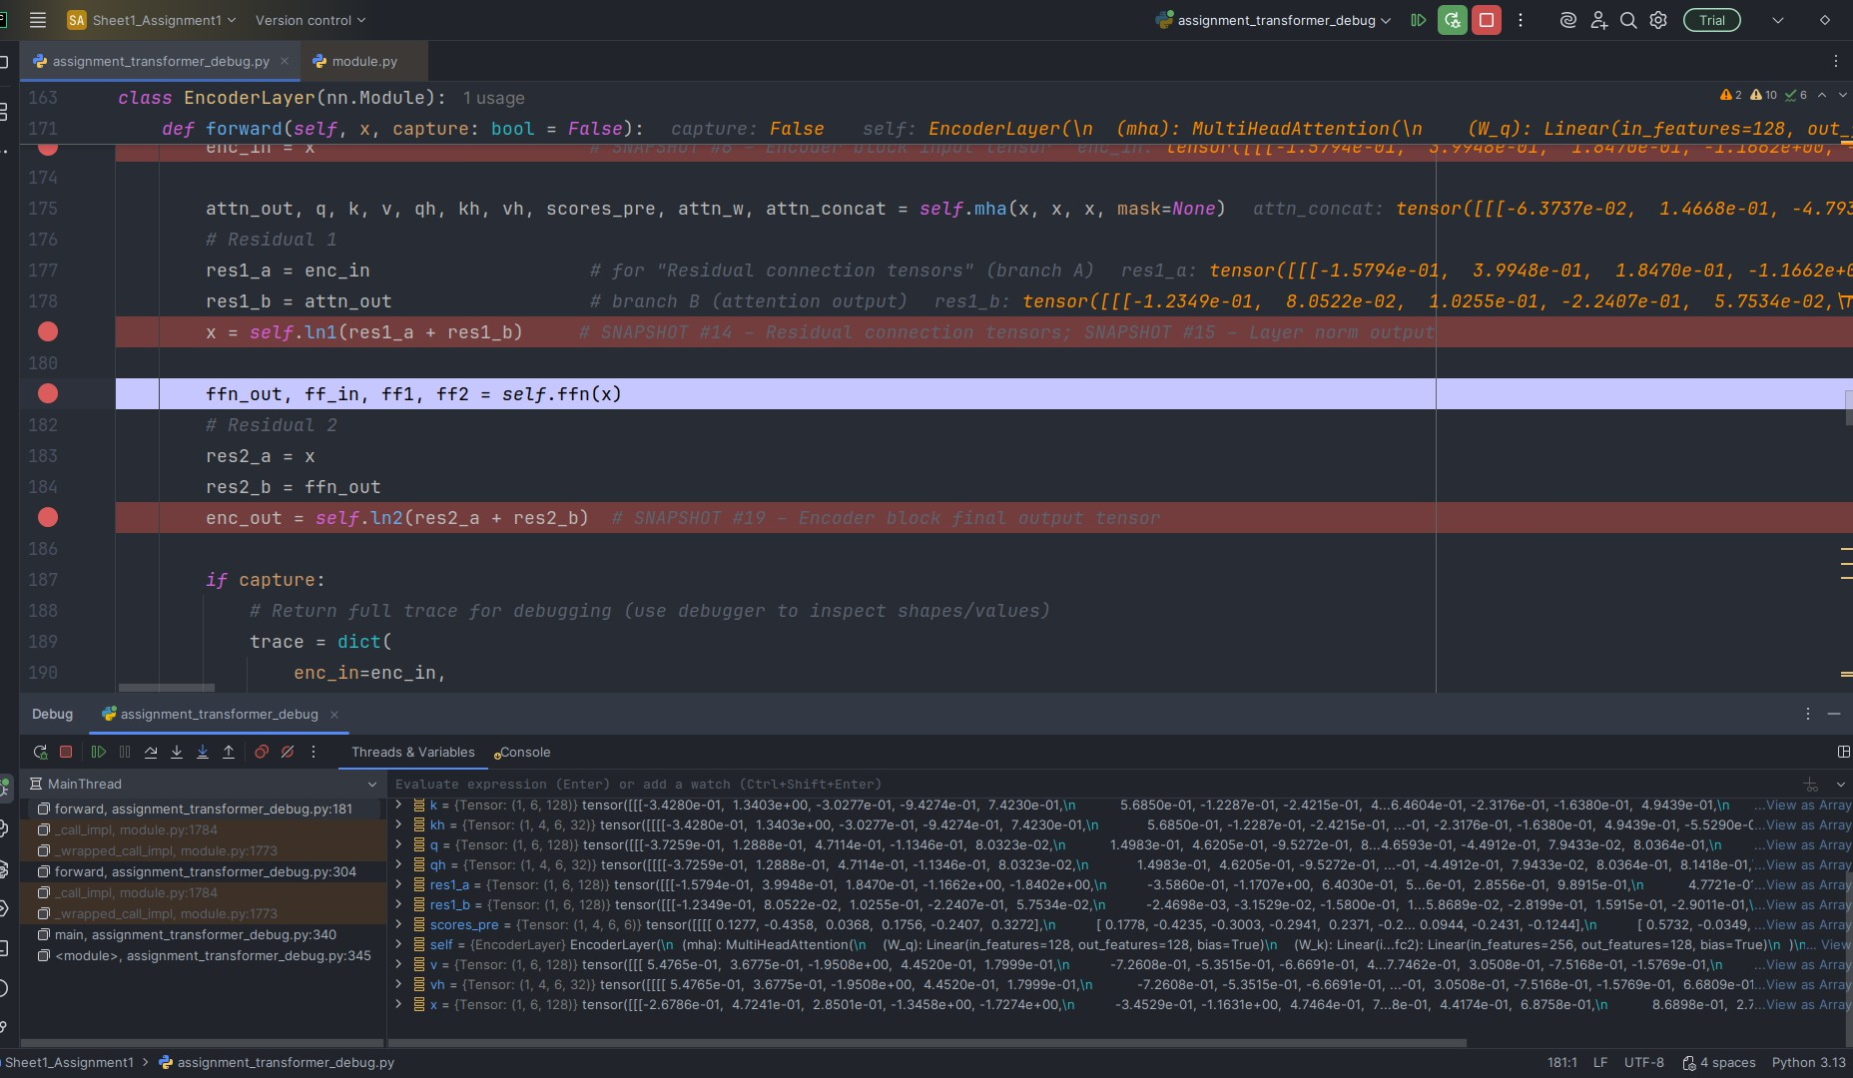

Snapshot #14 — Residual connection tensors

**Explanation & Shape**

**Variable (as shown in PyCharm):**

refs["enc_traces"][0]["res1_a"],

refs["enc_traces"][0]["res1_b"]

**Observed shape:** (1,6,128) each

Residual adds attention output to the input tensor element-wise; identical shapes ensure valid addition and stable gradients.

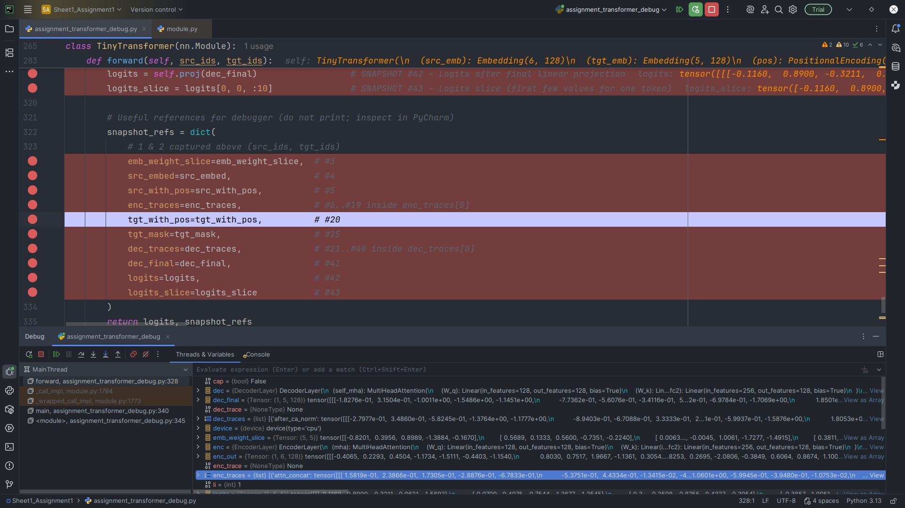

Snapshot #15 — Layer normalization output

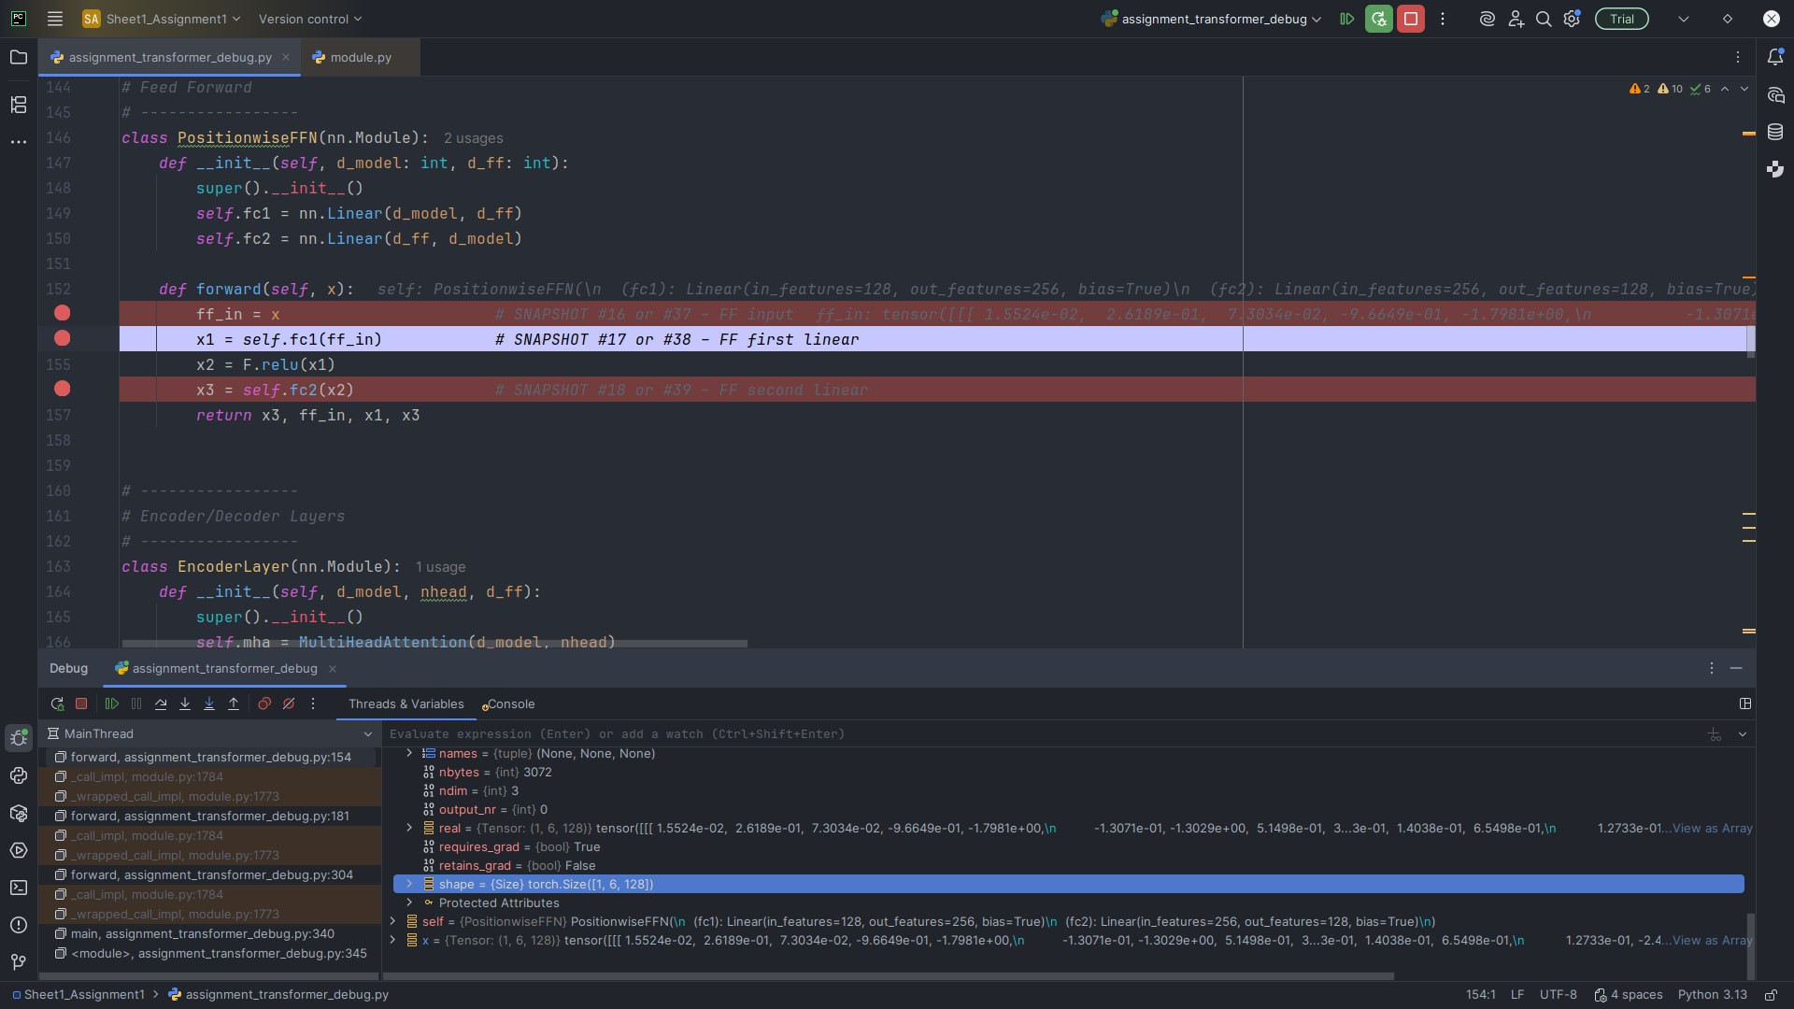

**Explanation & Shape**

**Variable (as shown in PyCharm):** refs["enc_traces"][0]["ln1_out"]

**Observed shape:** (1,6,128)

LayerNorm re-scales the residual sum per feature without changing shape, stabilizing training.

Snapshot #16 — Feed-forward input

**Explanation & Shape**

**Variable (as shown in PyCharm):** refs["enc_traces"][0]["ff_in"]

**Observed shape:** (1,6,128)

Normalized token states feed the position-wise FFN; *d*model = 128 is preserved for residuals.

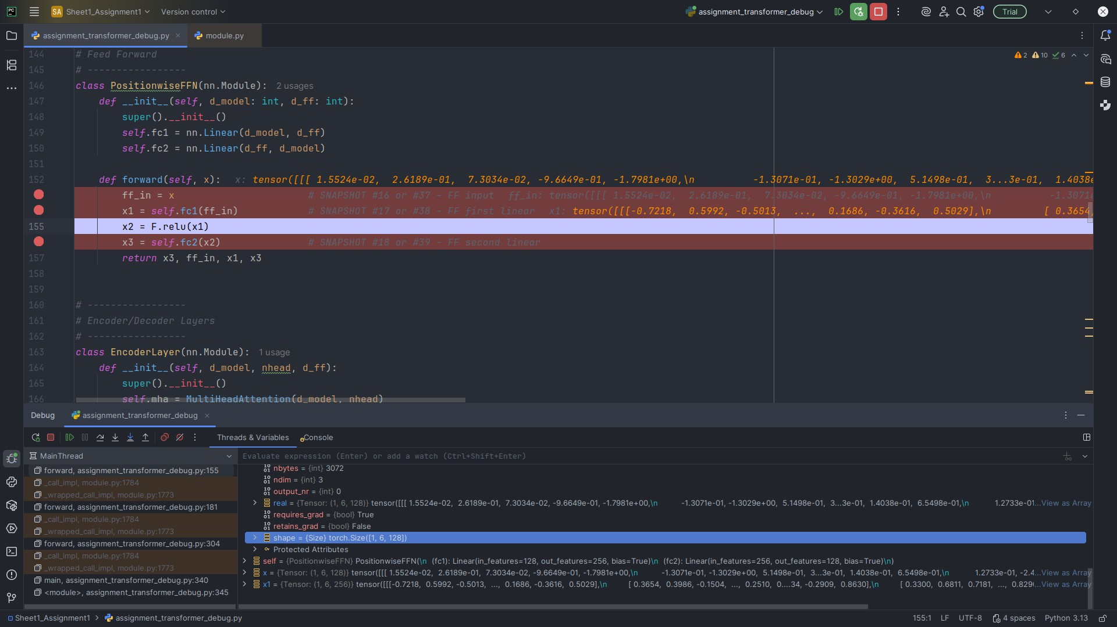

Snapshot #17 — Feed-forward first linear layer output

**Explanation & Shape**

**Variable (as shown in PyCharm):** refs["enc_traces"][0]["ff1"]

**Observed shape:** (1,6,256)

FFN expands to *d*ff = 256, increasing per-token capacity before projecting back.

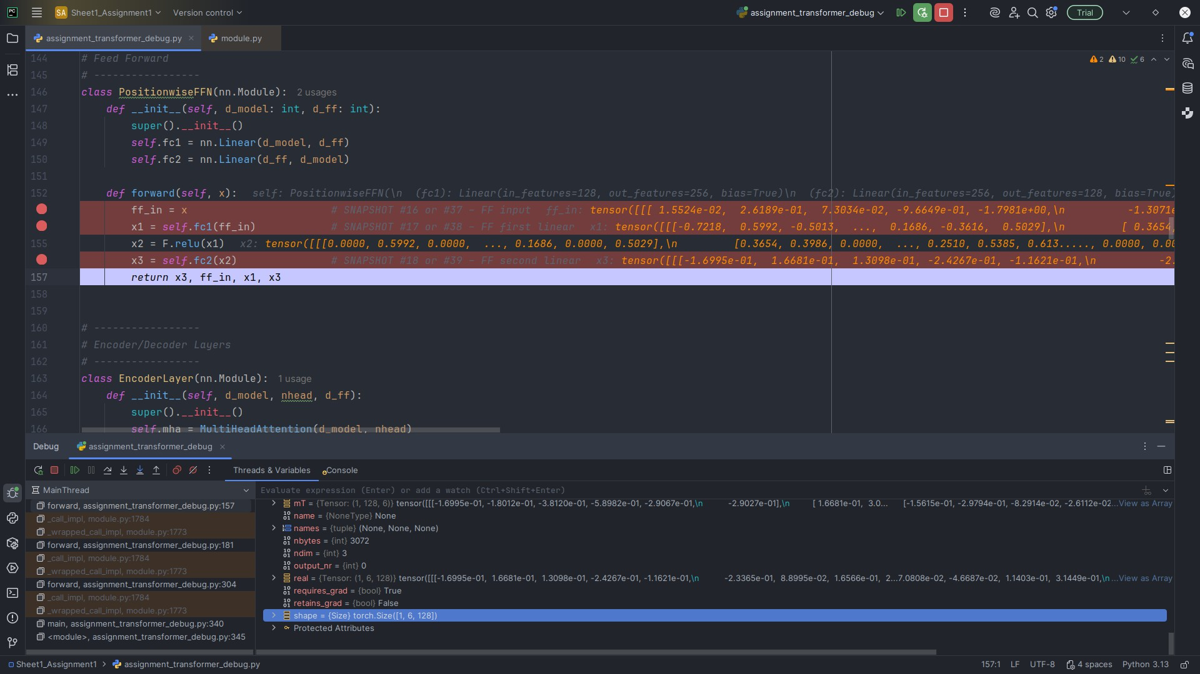

Snapshot #18 — Feed-forward second linear layer output

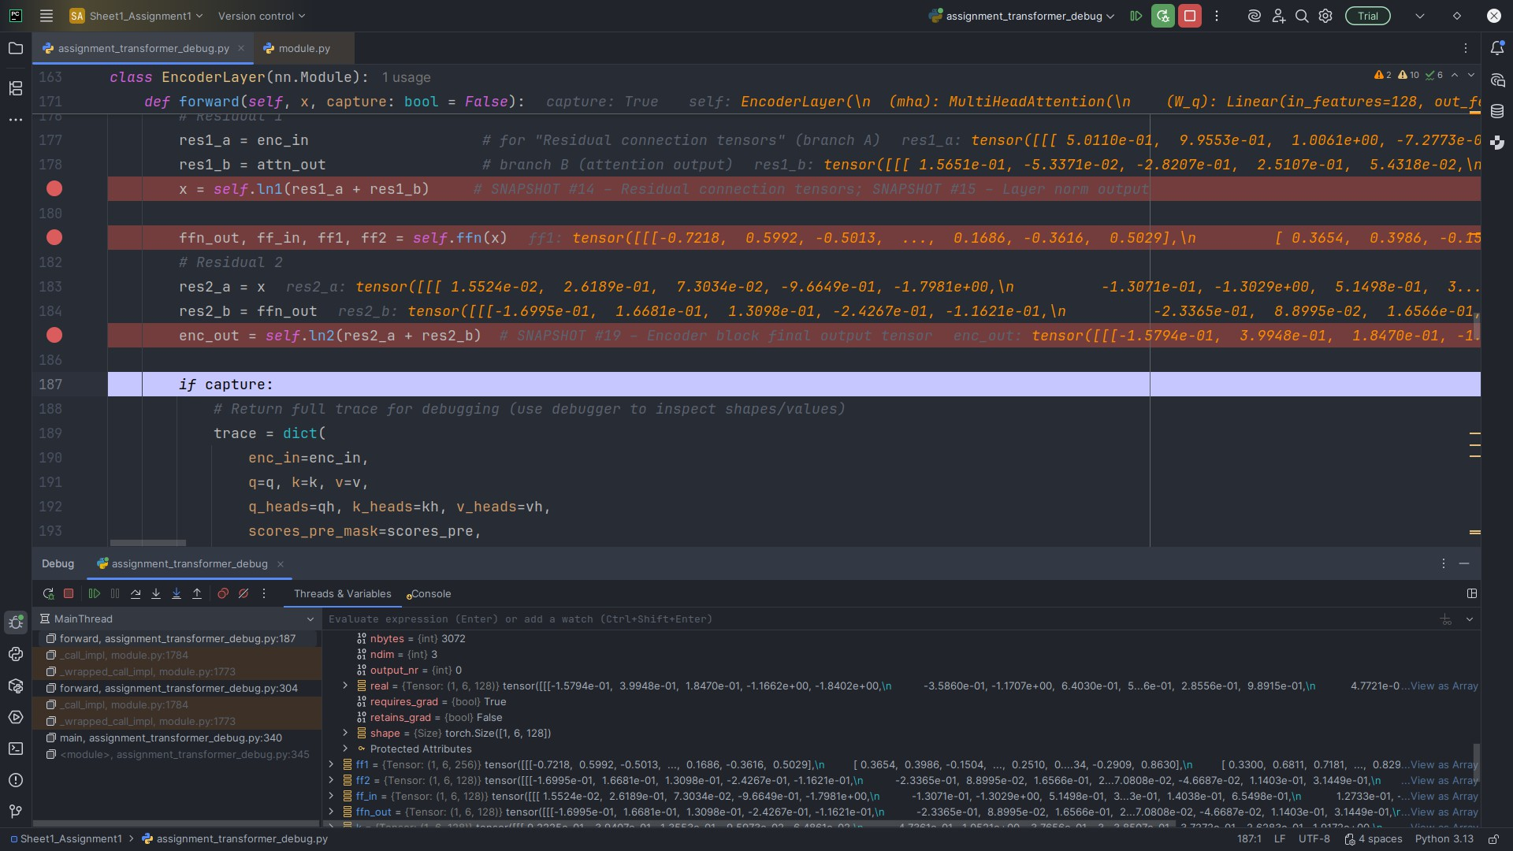

**Explanation & Shape**

**Variable (as shown in PyCharm):** refs["enc_traces"][0]["ff2"]

**Observed shape:** (1,6,128)

Projects back to 128 so it can be added (residual) to the FFN input.

Snapshot #19 — Encoder block final output tensor

**Explanation & Shape**

**Variable (as shown in PyCharm):** refs["enc_traces"][0]["enc_out"]

**Observed shape:** (1,6,128)

After FFN residual + LayerNorm, this output feeds later encoder layers and decoder cross-attention.

# Decoder (One Block, Full Trace) — Snapshots 20–40

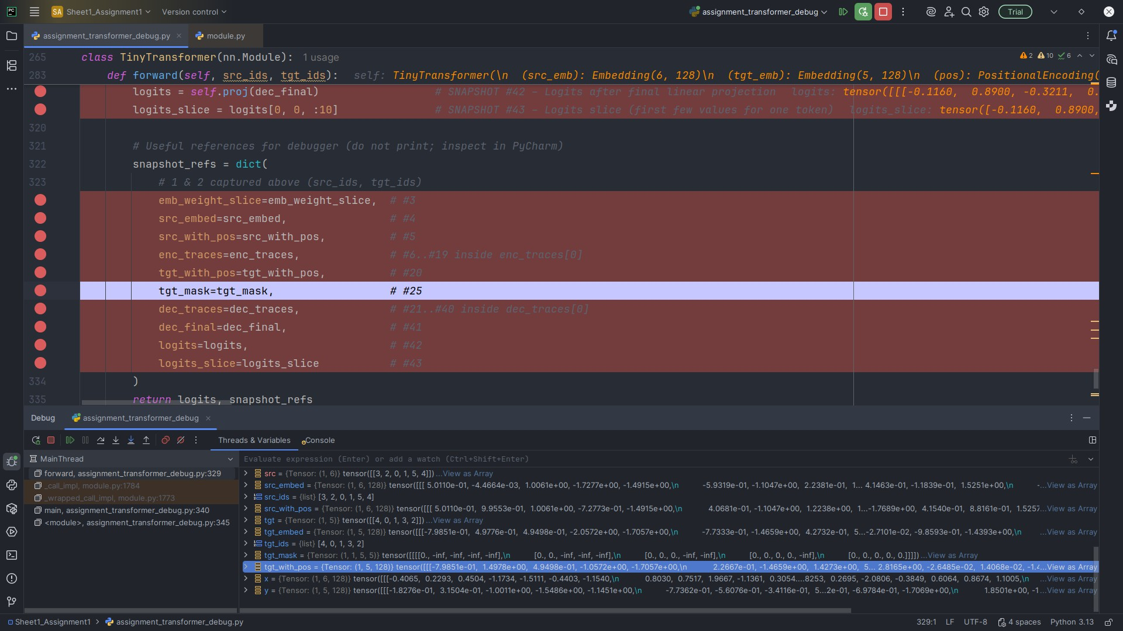

Snapshot #20 — Decoder block input tensor

**Explanation & Shape**

**Variable (as shown in PyCharm):** refs["tgt_with_pos"]

**Observed shape:** (1,5,128)

Target embeddings + positional encodings (teacher forcing). Target sequence length is 5.



Snapshot #21 — Masked self-attention queries (Q)



**Explanation & Shape**

**Variable (as shown in PyCharm):** refs["dec_traces"][0]["q_m"]

**Observed shape:** (1,5,128)

Decoder Q is a linear projection of decoder inputs; same shape as K,V to enable attention.

Snapshot #22 — Masked self-attention keys (K)

**Explanation & Shape**

**Variable (as shown in PyCharm):** refs["dec_traces"][0]["k_m"]

**Observed shape:** (1,5,128)

Decoder K shares the same shape so *QK𝖳* is valid across time steps.



Snapshot #23 — Masked self-attention values (V)

**Explanation & Shape**

**Variable (as shown in PyCharm):** refs["dec_traces"][0]["v_m"]

**Observed shape:** (1,5,128)

V provides features to be aggregated via masked attention weights.



Snapshot #24 — Masked attention scores before mask

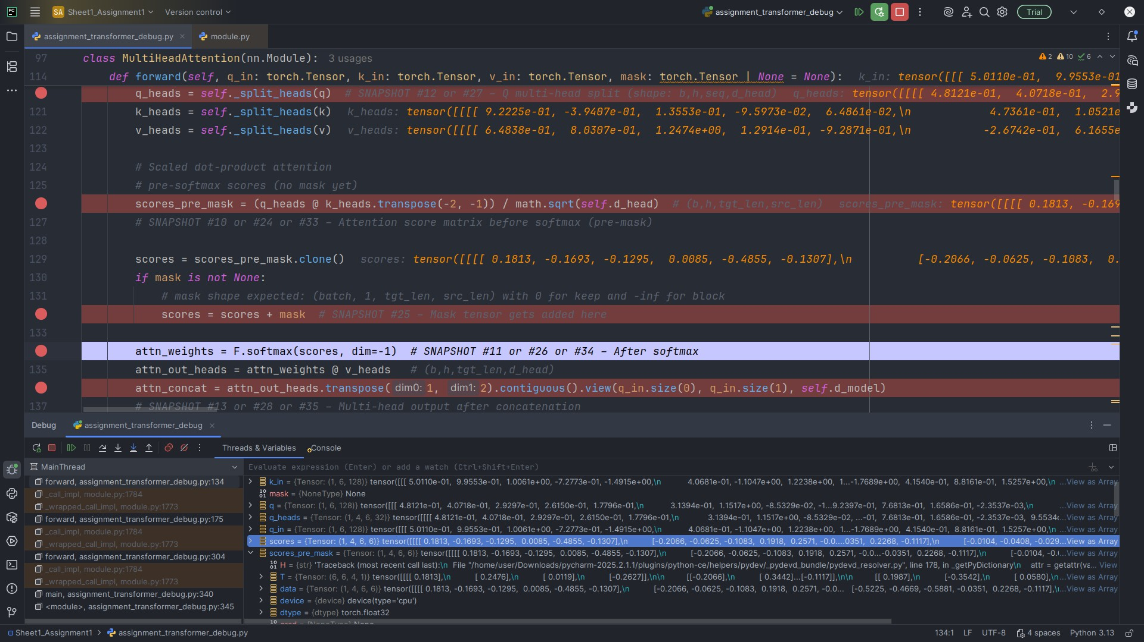

**Explanation & Shape**

**Variable (as shown in PyCharm):** refs["dec_traces"][0]["scores_pre_mask_m"]

**Observed shape:** (1,4,5,5)

Raw per-head scores before masking; square because masked self-attention is over the target sequence.

Snapshot #25 — Mask tensor

**Explanation & Shape**

**Variable (as shown in PyCharm):** refs["tgt_mask"]

**Observed shape:** (1,1,5,5) with 0 and −∞

Upper-triangular −∞ above the diagonal prevents attention to future positions, enforcing

autoregressive decoding.



Snapshot #26 — Masked attention scores after mask + softmax

**Explanation & Shape**

**Variable (as shown in PyCharm):** refs["dec_traces"][0]["attn_weights_m"]

**Observed shape:** (1,4,5,5)

After mask + softmax, probabilities at masked positions are ≈ 0; rows sum to ≈ 1.



Snapshot #27 — Masked self-attention multi-head split



**Explanation & Shape**

**Variable (as shown in PyCharm):**

k_heads_m, v_heads_m)

**Observed shape:** (1,4,5,32) each

refs["dec_traces"][0]["q_heads_m"]

(&

Splitting into 4 heads of 32 captures multiple relations per token in parallel.

Snapshot #28 — Masked self-attention multi-head concatenated output

**Explanation & Shape**

**Variable (as shown in PyCharm):** refs["dec_traces"][0]["attn_concat_m"]

**Observed shape:** (1,5,128)

Per-head outputs are concatenated to 128 to preserve residual compatibility.

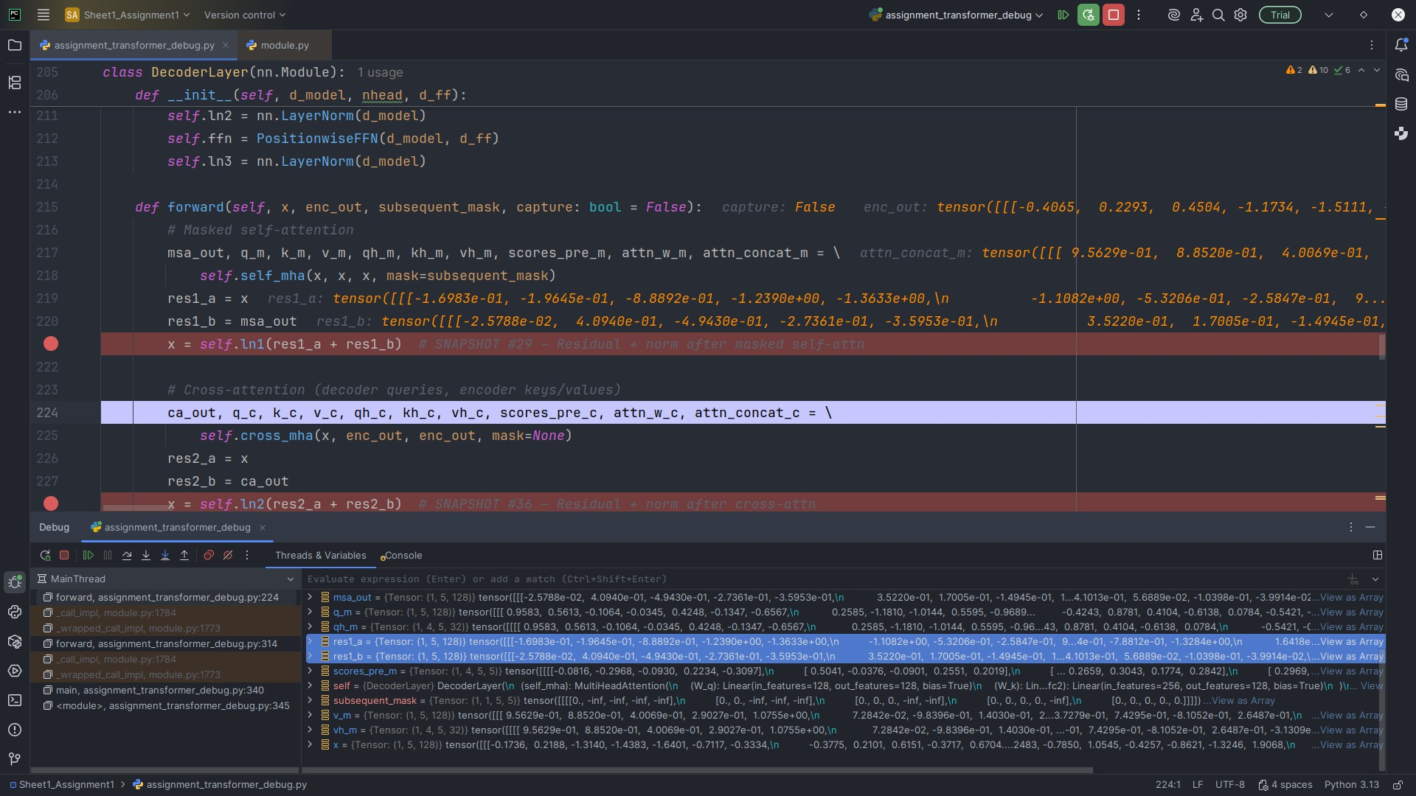

Snapshot #29 — Residual + normalization after masked self-attention

**Explanation & Shape**

**Variable (as shown in PyCharm):** refs["dec_traces"][0]["after_msa_norm"]

**Observed shape:** (1,5,128)

Residual (decoder input + masked self-attn output) followed by LayerNorm; shape un- changed.



Snapshot #30 — Cross-attention queries (from decoder)



**Explanation & Shape**

**Variable (as shown in PyCharm):** refs["dec_traces"][0]["q_c"]

**Observed shape:** (1,5,128)

Queries derived from decoder states to attend over encoder outputs.

Snapshot #31 — Cross-attention keys (from encoder)

**Explanation & Shape**

**Variable (as shown in PyCharm):** refs["dec_traces"][0]["k_c"]

**Observed shape:** (1,6,128)

Keys originate from encoder outputs (src length = 6).



Snapshot #32 — Cross-attention values (from encoder)

**Explanation & Shape**

**Variable (as shown in PyCharm):** refs["dec_traces"][0]["v_c"]

**Observed shape:** (1,6,128)

Values also come from encoder outputs and will be aggregated into decoder states.



Snapshot #33 — Cross-attention score matrix before softmax



**Explanation & Shape**

**Variable (as shown in PyCharm):** refs["dec_traces"][0]["scores_pre_mask_c"]

**Observed shape:** (1,4,5,6)

Per-head scores are rectangular (tgt_len = 5 queries over src_len = 6 keys).

Snapshot #34 — Cross-attention score matrix after softmax

**Explanation & Shape**

**Variable (as shown in PyCharm):** refs["dec_traces"][0]["attn_weights_c"]

**Observed shape:** (1,4,5,6)

Row-wise probabilities over encoder positions; each row sums ≈ 1.



Snapshot #35 — Cross-attention output after concatenation

**Explanation & Shape**

**Variable (as shown in PyCharm):** refs["dec_traces"][0]["attn_concat_c"]

**Observed shape:** (1,5,128)

Concatenated per-head outputs, restoring *d*model = 128 for residual addition.

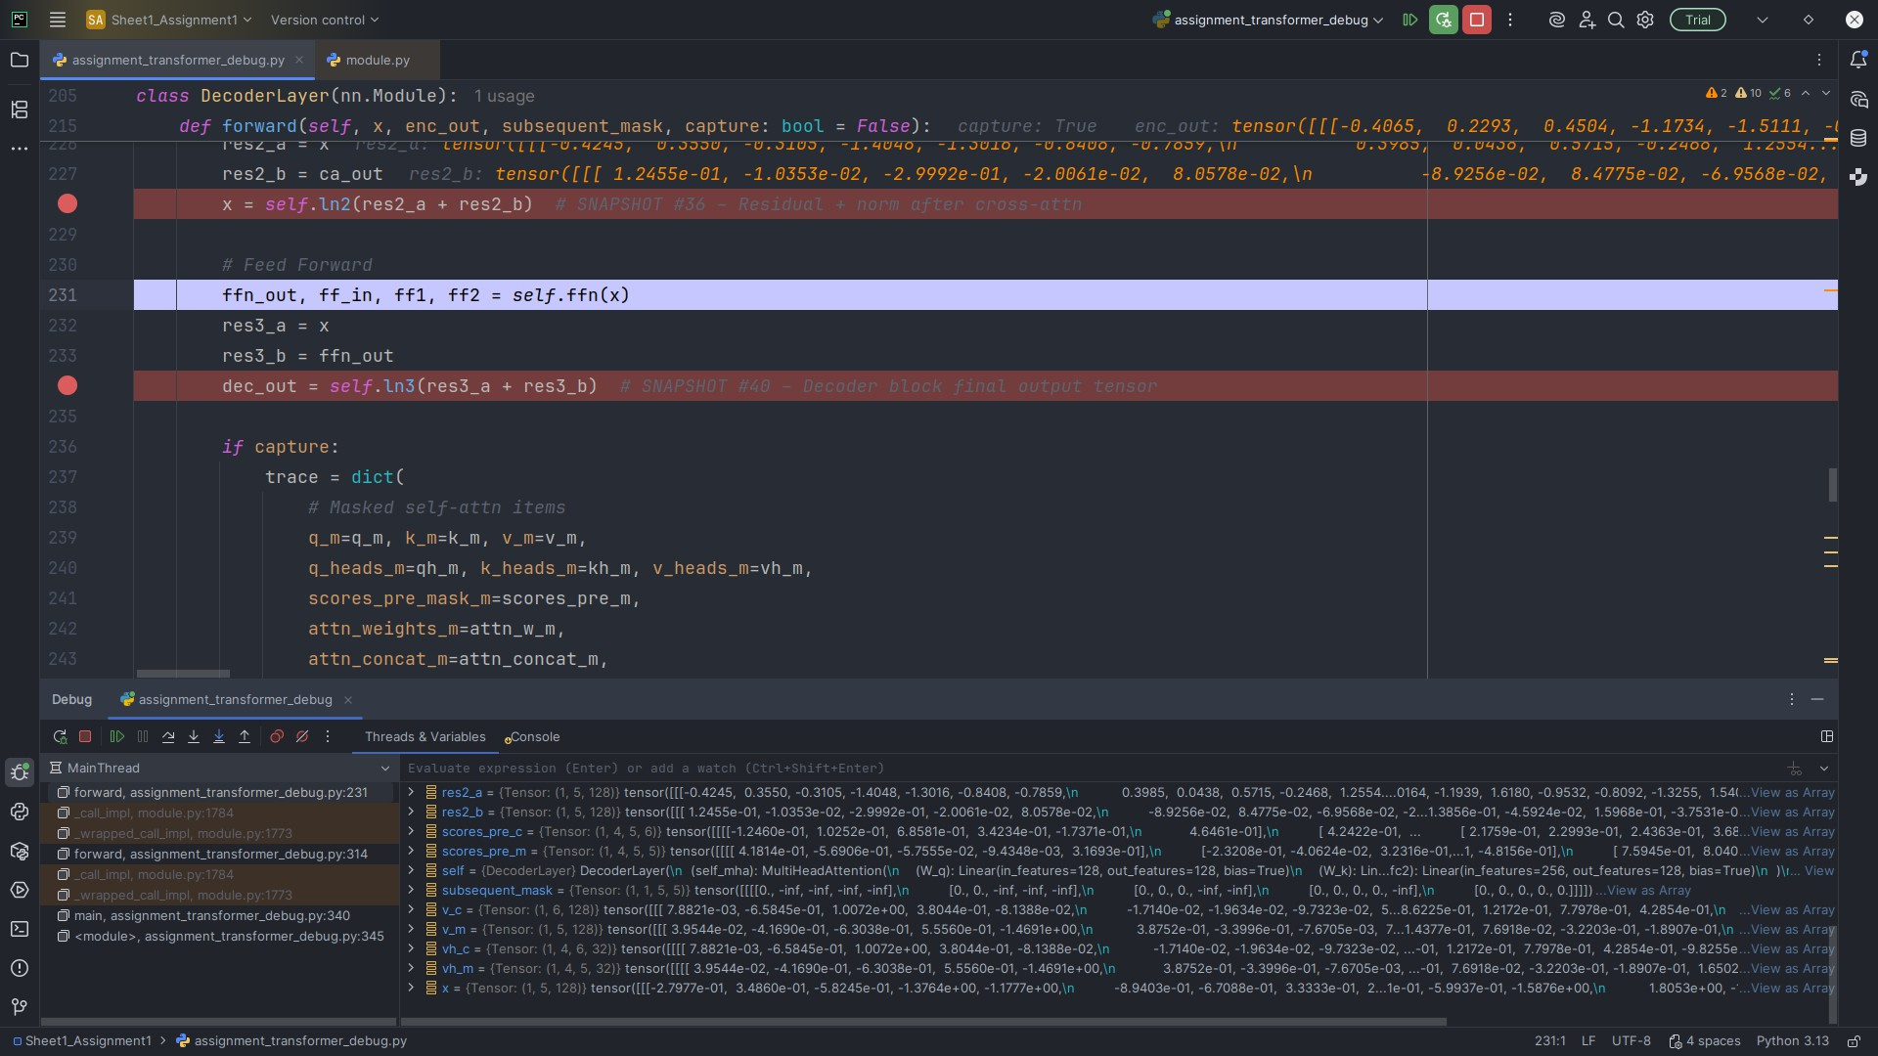

Snapshot #36 — Residual + normalization after cross-attention



**Explanation & Shape**

**Variable (as shown in PyCharm):** refs["dec_traces"][0]["after_ca_norm"]

**Observed shape:** (1,5,128)

Residual (decoder state + cross-attn output) then LayerNorm; shape stays (1*,* 5*,* 128).

Snapshot #37 — Decoder feed-forward input

**Explanation & Shape**

**Variable (as shown in PyCharm):** refs["dec_traces"][0]["ff_in"]

**Observed shape:** (1,5,128)

Input to the decoder FFN; *d*model stays constant across blocks to support residuals.



Snapshot #38 — Feed-forward first linear layer output

**Explanation & Shape**

**Variable (as shown in PyCharm):** refs["dec_traces"][0]["ff1"]

**Observed shape:** (1,5,256)

Expanded to *d*ff = 256 for more capacity and non-linearity.



Snapshot #39 — Feed-forward second linear layer output

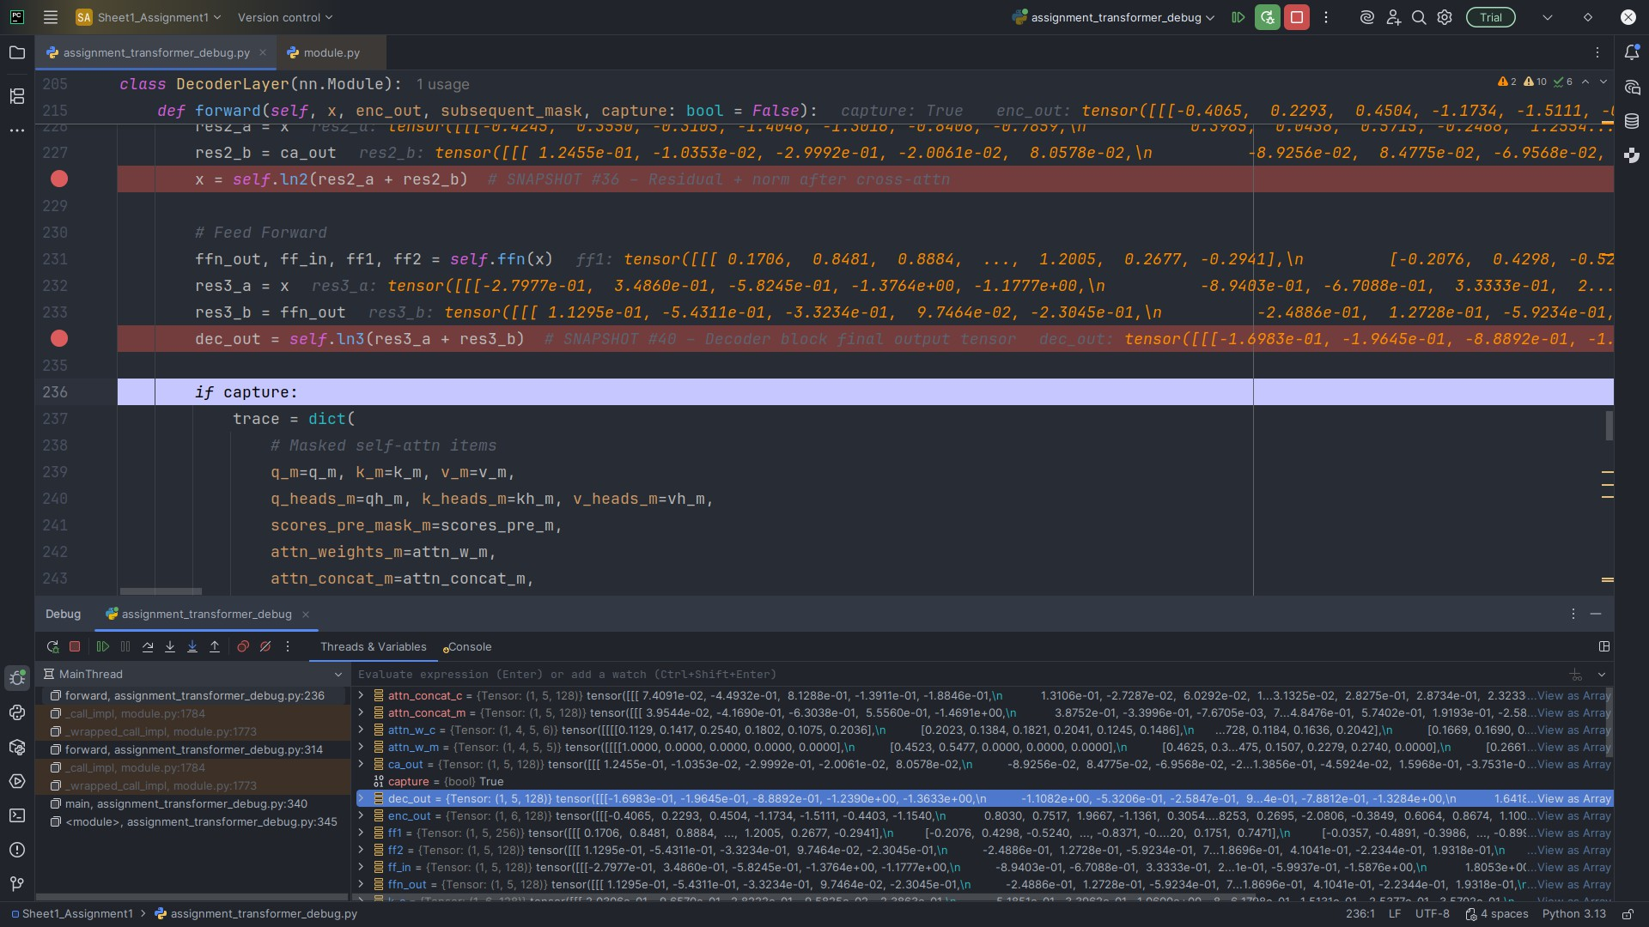

**Explanation & Shape**

**Variable (as shown in PyCharm):** refs["dec_traces"][0]["ff2"]

**Observed shape:** (1,5,128)

Projected back to 128 to match the residual branch.

Snapshot #40 — Decoder block final output tensor

**Explanation & Shape**

**Variable (as shown in PyCharm):** refs["dec_traces"][0]["dec_out"]

**Observed shape:** (1,5,128)

Output of the decoder block after FFN residual + LayerNorm; feeds the next decoder layer or final projection.

# Final Output (Snapshots 41–43)

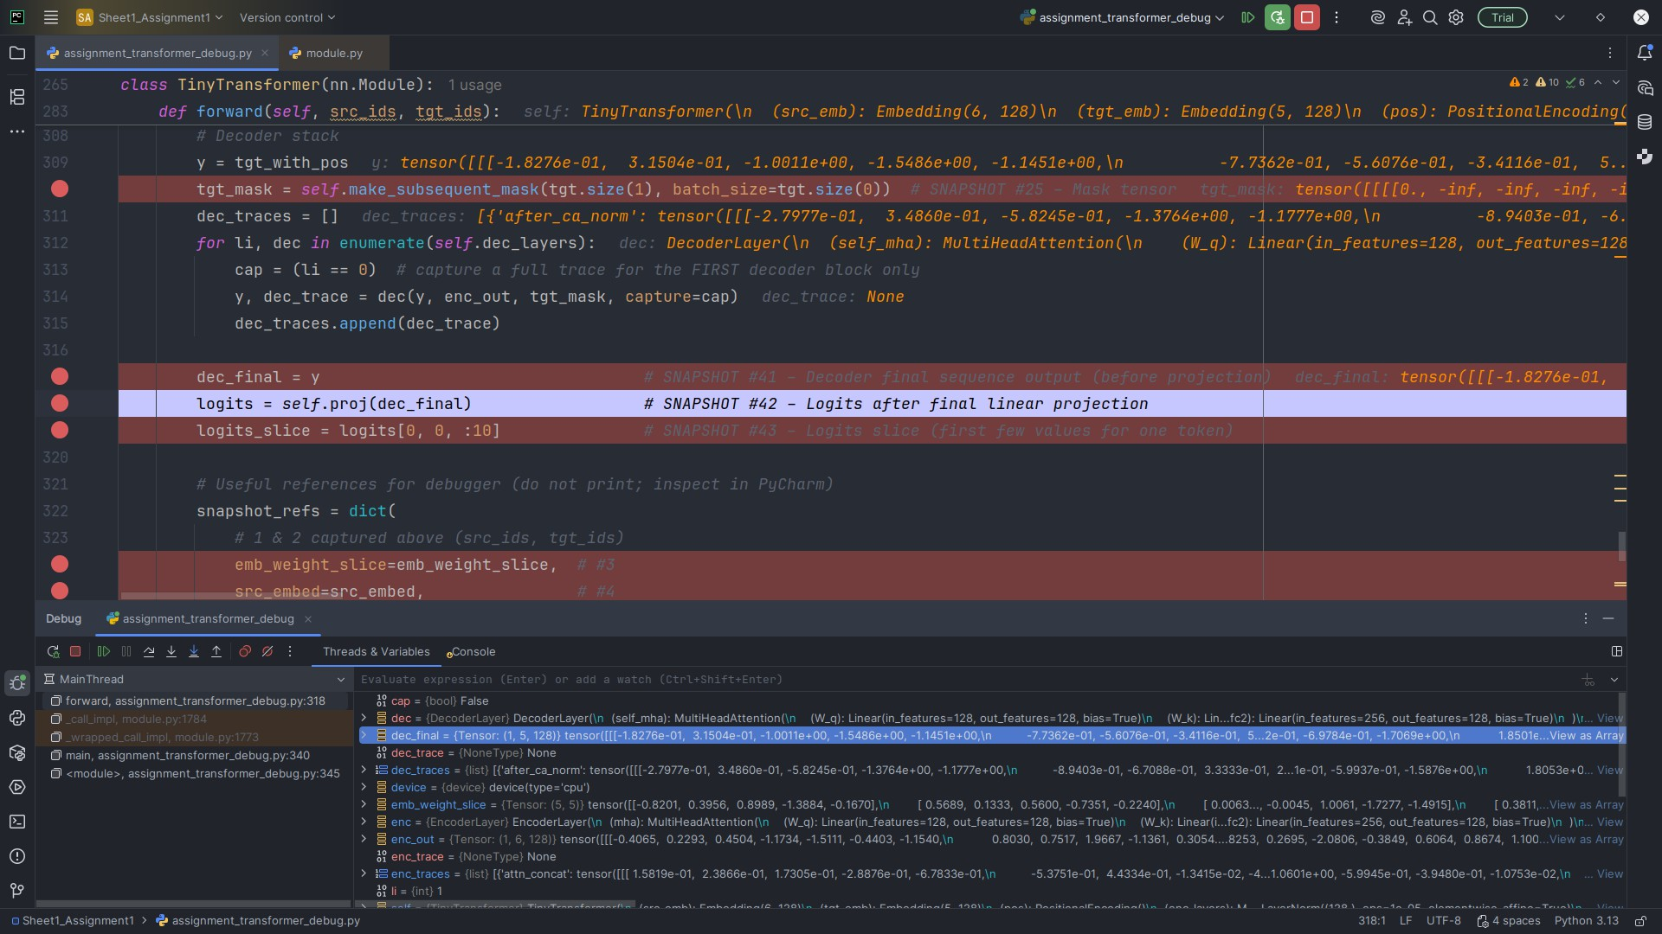

Snapshot #41 — Decoder final sequence output (before projection)

**Explanation & Shape**

**Variable (as shown in PyCharm):** refs["dec_final"]

**Observed shape:** (1,5,128)

Final decoder hidden states after all decoder layers; still in model space 128.

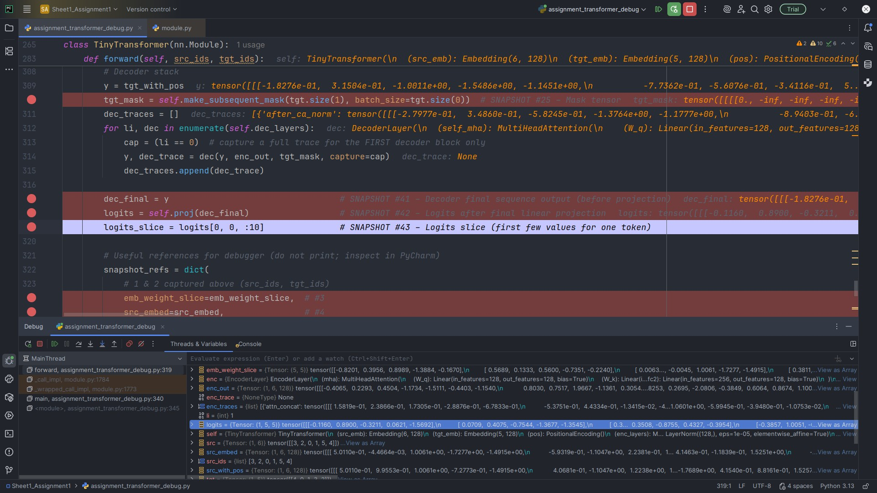

Snapshot #42 — Logits after final linear projection

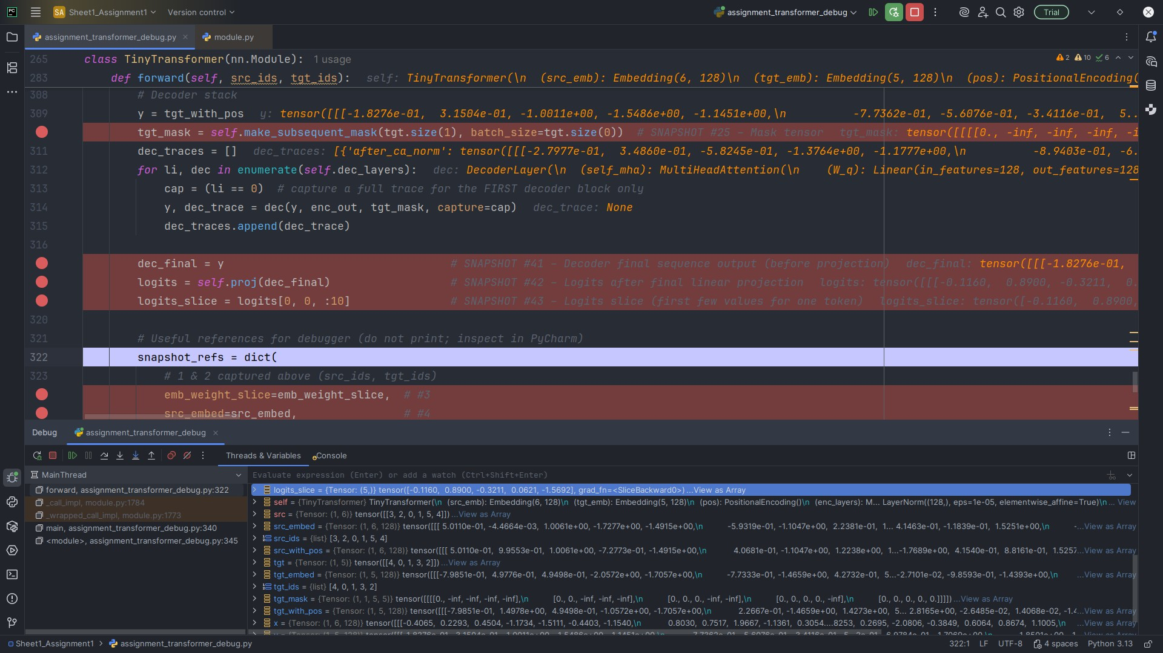

**Explanation & Shape**

**Variable (as shown in PyCharm):** refs["logits"]

**Observed shape:** (1,5,*tgt_vocab_size*)

A linear map converts 128 → *vocab_size* per time step, producing unnormalized log-

probabilities (logits) over the target vocabulary.

Snapshot #43 — Logits slice (first few values for one token)

**Explanation & Shape**

**Variable (as shown in PyCharm):** refs["logits_slice"]

**Observed shape:** ( ≤ 10 elements )

A small slice of a token’s logits for quick sanity-check: confirms projection and vocab dimension are correct.

# Guiding Questions — Answers

1. **What do the dimensions represent at embedding, attention, FFN, and output stages?**

Embeddings use (batch*,* seq_len*, d*model). Attention uses (batch*,* heads*,* tgt_len*,* src_len) for scores/weights and (batch*,* heads*,* seq_len*, d*head) for per-head Q/K/V and outputs, with *d*head = *d*model*/*heads. The FFN preserves ( *, , d*model) externally while expanding internally to *d*ff then projecting back. Logits are (batch*,* seq_len*,* vocab_size).

· ·

1. **Why do Q, K, V have the same shape, and why split heads?**

They’re linear projections of the same *d*model-dimensional token states so dot products *QK𝖳* and weighted sums on *V* are compatible. Splitting into heads lets the model attend to different subspaces in parallel.

1. **What do the attention score matrices represent, and why square?**

They are scaled dot-product affinities between queries and keys per head. In self-attention, target and source are the same sequence, so the matrix is square (seq × seq). In cross-attention, it’s rectangular (tgt_len × src_len).

1. **Why is masking necessary in the decoder, and how does the mask enforce it?** Masking prevents access to future positions during training. Adding above the diagonal before softmax forces those probabilities to 0, ensuring autoregressive behavior.

−∞

1. **How do residuals and LayerNorm ensure consistency of shapes across blocks?** Residuals require identical shapes so sublayers return *d*model; LayerNorm normalizes features without changing dimensions, stabilizing depth.
2. **Why keep the embedding dimension constant through layers?**

A fixed *d*model keeps interfaces consistent and enables valid residual additions across stacked blocks.

1. **How does the final projection connect decoder output to vocabulary logits?** A learned linear map applies at each time step: *W* R*d*model*×*vocab_size, producing logits over the target vocabulary.

∈